Hack BI V JAVA: Downloading

horizontal line

Java JDK

1. Go to this link: https://www.oracle.com/java/technologies/javase downloads.html

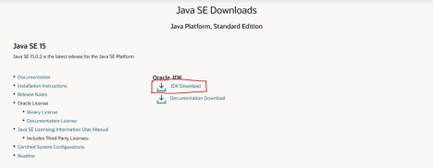

2. Download the Oracle Java JDK for Java SE 15

a. You might have to create an oracle account

jGrasp Download

1. Go to this link: https://spider.eng.auburn.edu/user

cgi/grasp/grasp.pl?;dl=download_jgrasp.html

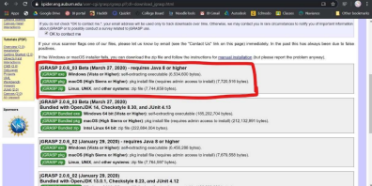

2. Download jGrasp for either Windows, mac, or Linux